

**ts_owrt_module**

**Debug in Eclipse IDE**

**1. Download and install Eclipse IDE**

Go to page:

*https://www.eclipse.org/downloads/packages/*

Download package:

*Eclipse IDE for C/C++ Developers*

Extract package to your working directory like "/home/openwrt/IDE/eclipse"

Run Eclipse:

/home/openwrt/IDE/eclipse/eclipse

**2. Add project**

Select

File -> New -> Makefile Project with Existing Code

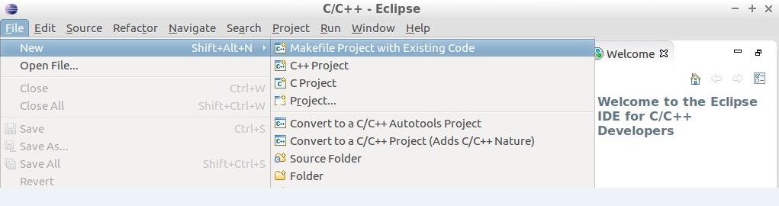

Chose your project location an press finish

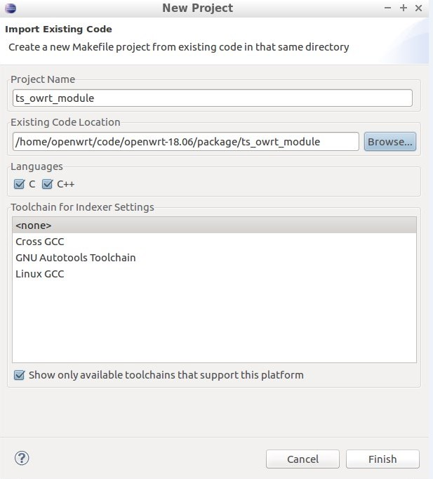

Select your project in Project Explorer, press right button and chose *Properties.*

Go to C/C++ Build. Fill *Builder Settings* like on screen.

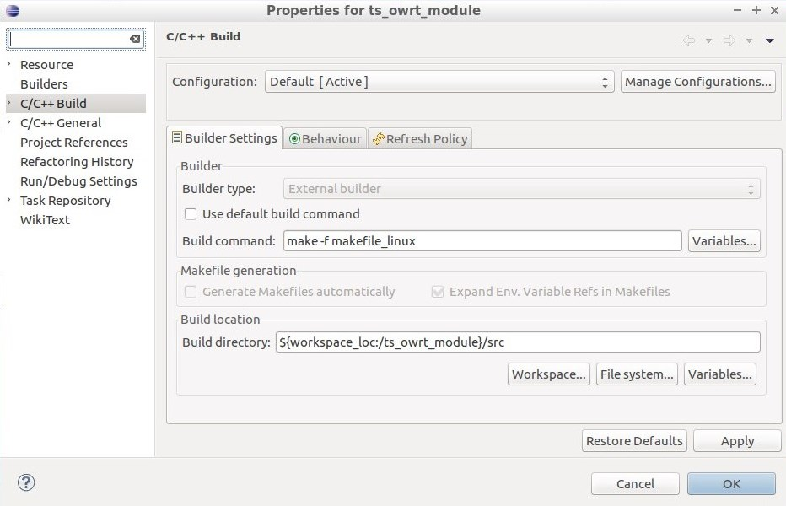

Go to *Run/Debug Settings* and press *New,* select *C/C++ Application*

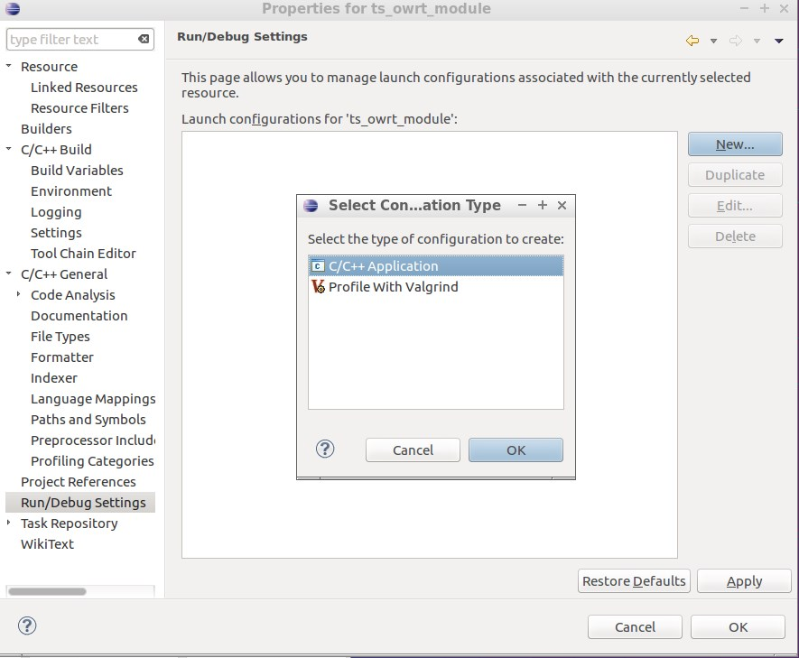

Fill *main* tab like on screen

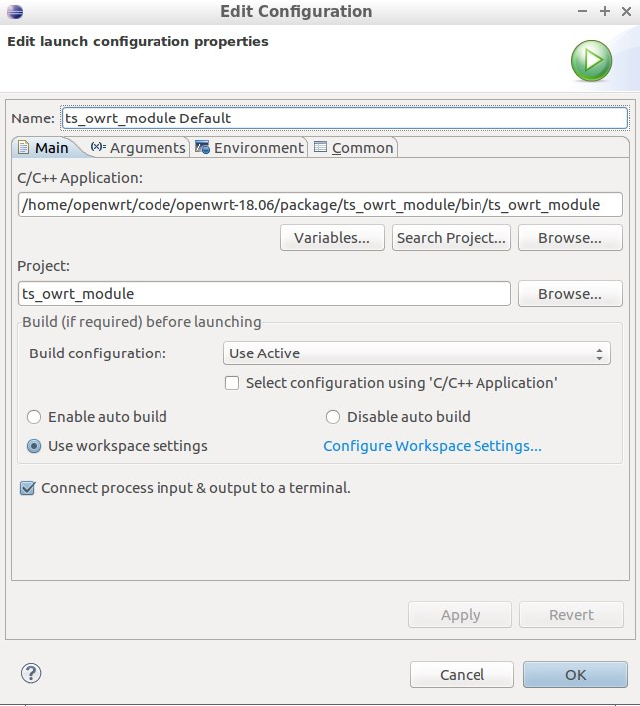

Fill *Common* tab like on screen and press *OK*

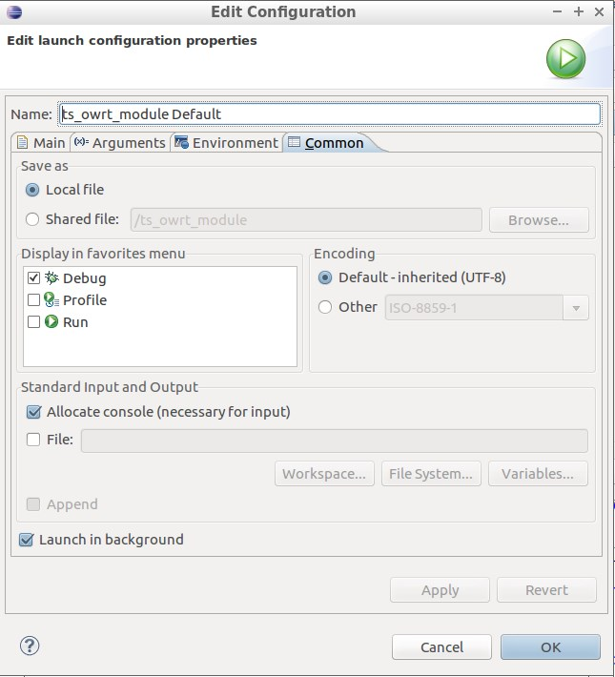

Now you can run project, chose Run -> Run

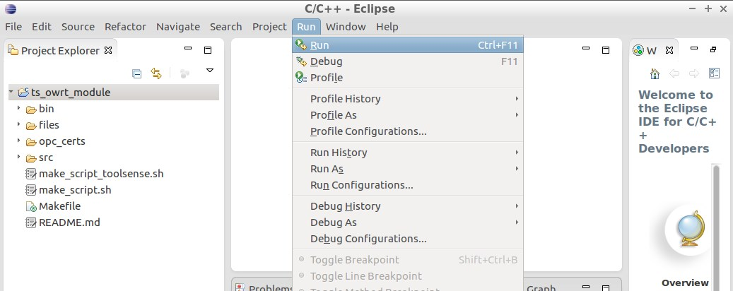

**3. Setup Debug**

Chose Run -> Debug Configurations

Press right button on *C/C++ Application* and chose *New*

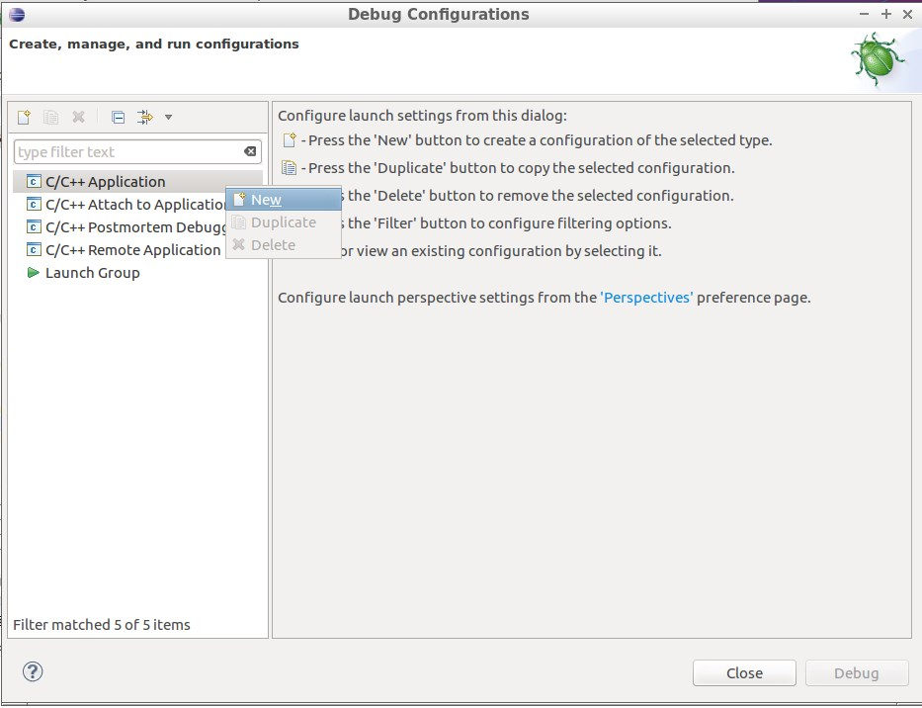

Fill *main* tab like on screen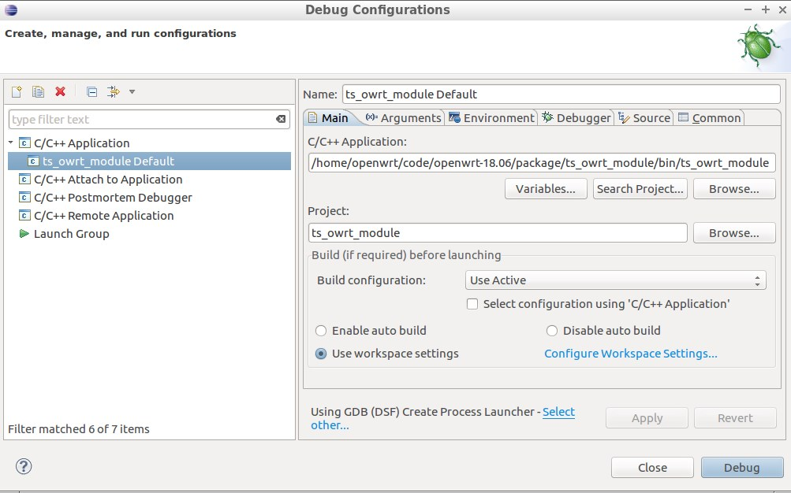

Fill *Arguments* tab like on screen (Uncheck *Use default*)

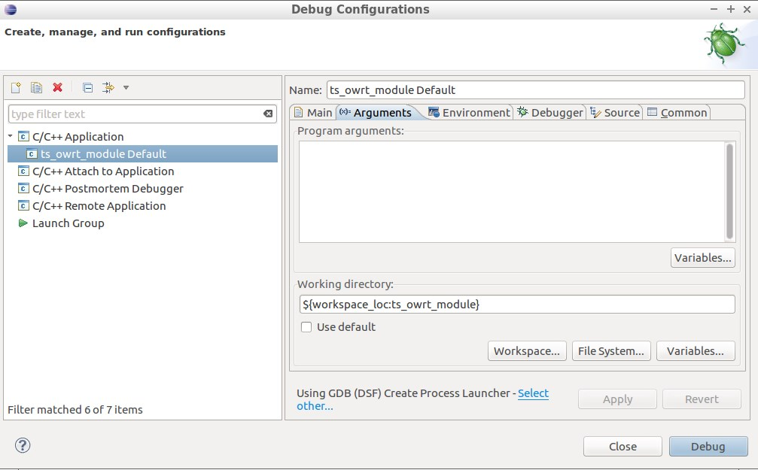

Fill *Debugger* tab like on screen

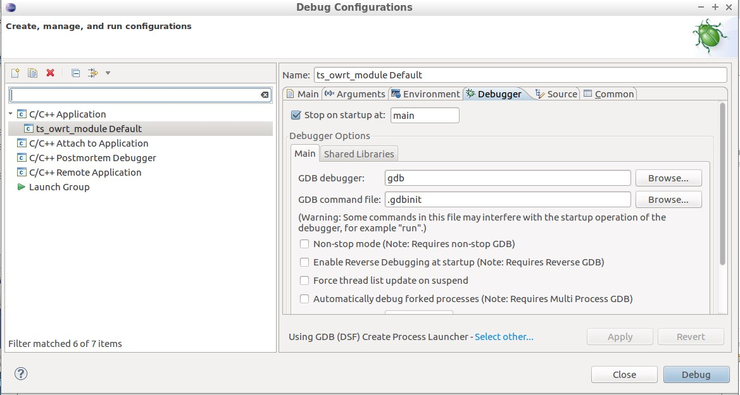

Go to *Source* tab and press *Add*

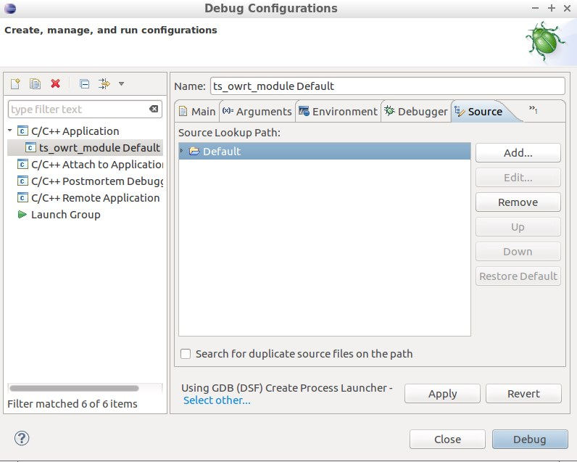

Chose *File System Directory*

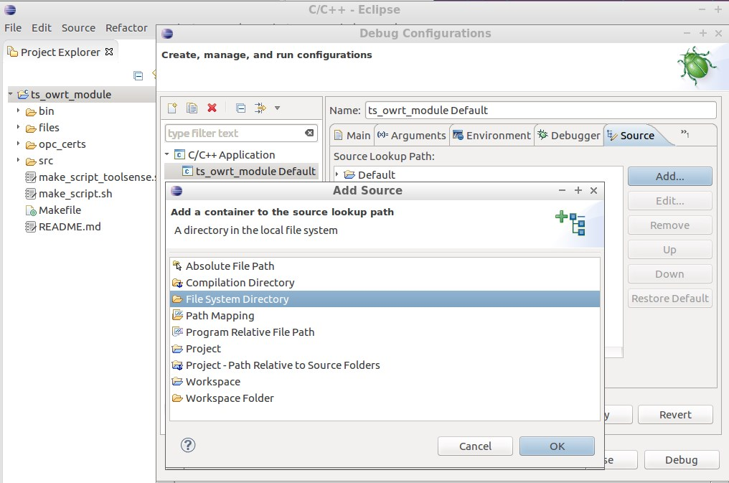

Fill path to your project *src* folder

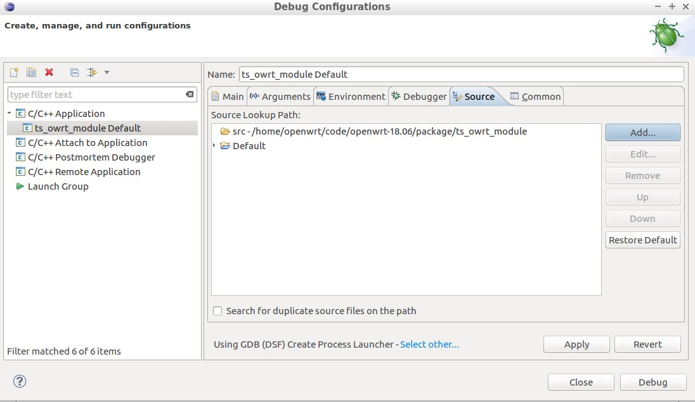

Press *Apply* and *Close*

Now you can run debug, chose Run -> Debug